Supply List: 5th Grade Gifted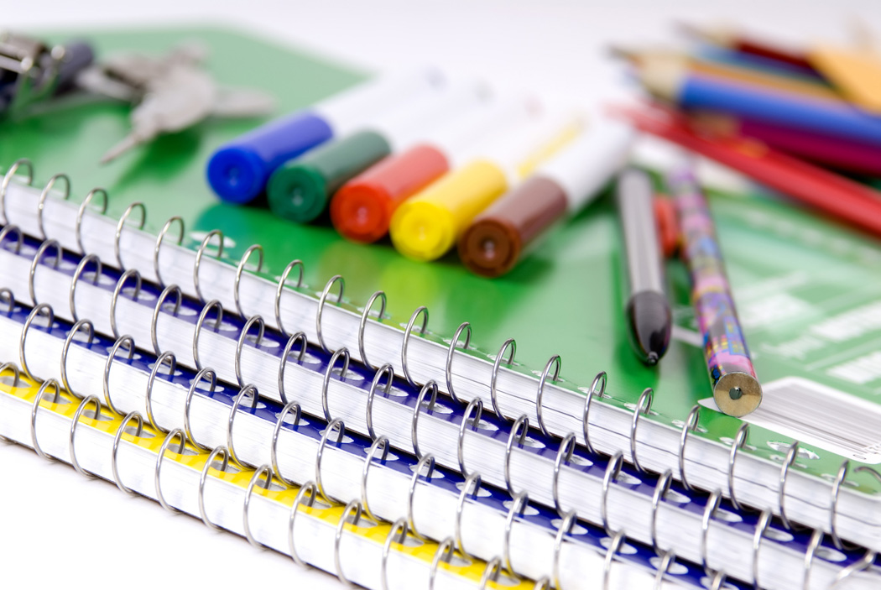

- PENS (BLACK AND RED)
- #2 PENCILS (12)
- COLORED PENCILS
- CRAYONS (1 BOX 24 PACK)
- MARKERS
- SMALL PENCIL SHARPENER WITH COVER
- HI-LITERS (YELLOW, BLUE, PINK, ORANGE)
- BLACK PERMENENT MARKER (2)
- ZIPPERED PENCIL CASE
- INDEX CARDS (2- 3X5 BLANK AND RULED)
- POST-IT NOTES
- HEADPHONES
- FLASHDRIVE
- LOOSE LEAF PAPER (2 PACKS)
- 1 SUBJECT SPIRAL NOTEBOOKS (6)
- 3-PRONG POCKET FOLDERS (6)
- 2 COMPOSITION NOTEBOOKS
- 2 INCH 3-RING BINDER
- SUBJECT DIVIDERS
- ZIP LOCK BAGS (5)
- GLUE STICKS (4)
- SCISSORS
- RULER (INCHES AND CETIMETERS)
- 1 PACKAGE OF COPY PAPER
- 2 BOXES OF KLEENEX
- 2 ROLLS OF PAPER TOWELS
- 2 BOTTLES OF HAND SANITIZER
- 1 BOX OF BAND-AIDS

